Name : Latrell Onofrio-Dewar | Student ID : N01652539
Name : | Student ID :
Date: 2026-04-19 | Professor Signature:

Lab 9– MIPS Architecture Design – CPU Code Execution

The purpose of this lab is to finish the CPU instruction functions required by the MIPS simulator we build in the last lab.
Procedures
- Hint: Starting from lab 7, the code will be more and more complicated. As a result, you should consider having a consistent development environment and backup your code more frequently.
- Study the MIPS instruction set definition based on the course materials and lecture notes. Follow the examples your professor gives you during the class time, make sure you understand the 32-bit instruction set structure and how to translate the assembly code into its 32-bit machine code.
- Now try to understand the code, and finish the following functions in lab8_9.c:
CPU_Execution(unsigned char opcode, unsigned int machineCode, char *mem)
- Uncomment the following statement in lab8_9.c, so that function CPU_Execution will be included into the project.
// CPU_Execution(opcode, machineCode, mem);

Please follow the following submission requirements for this lab:
- Must demo your code to the professor to get the signature from the professor. (50%)
- Submit the screenshots of the running results and the final memory dump of Data section, and all the register contents. Screenshots must have time/date of the local computer. (30%)
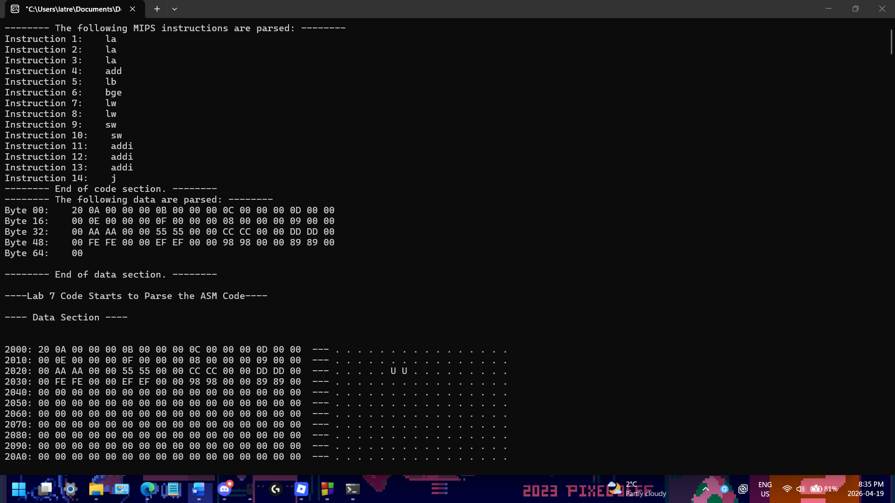
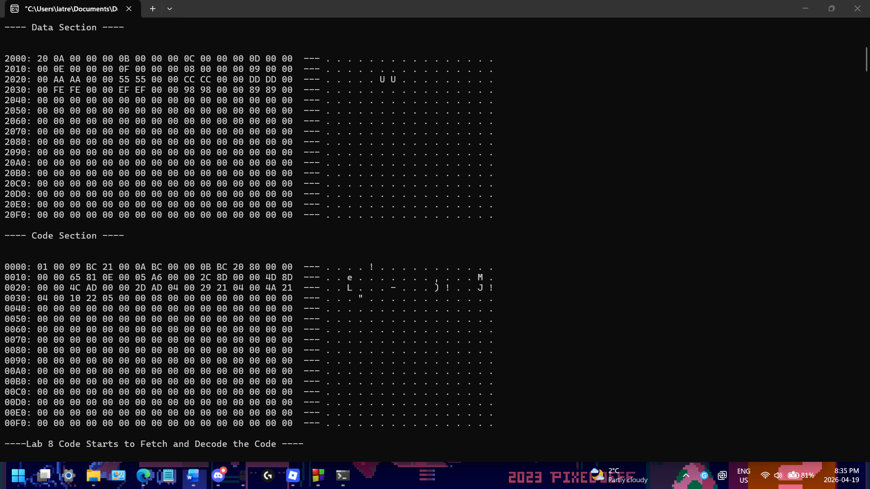
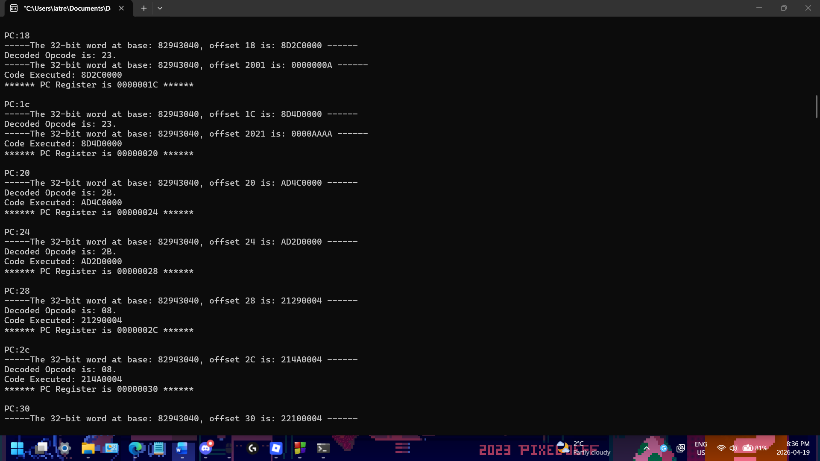
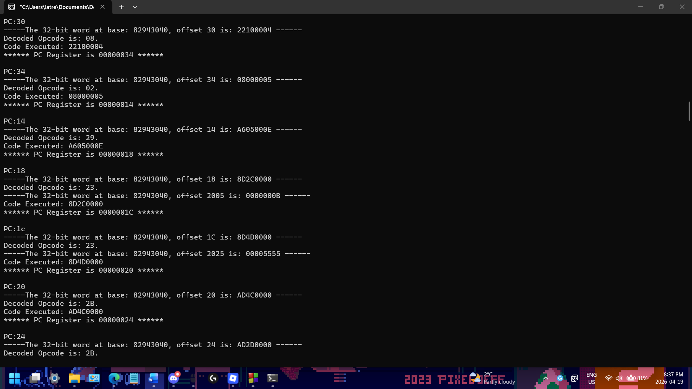
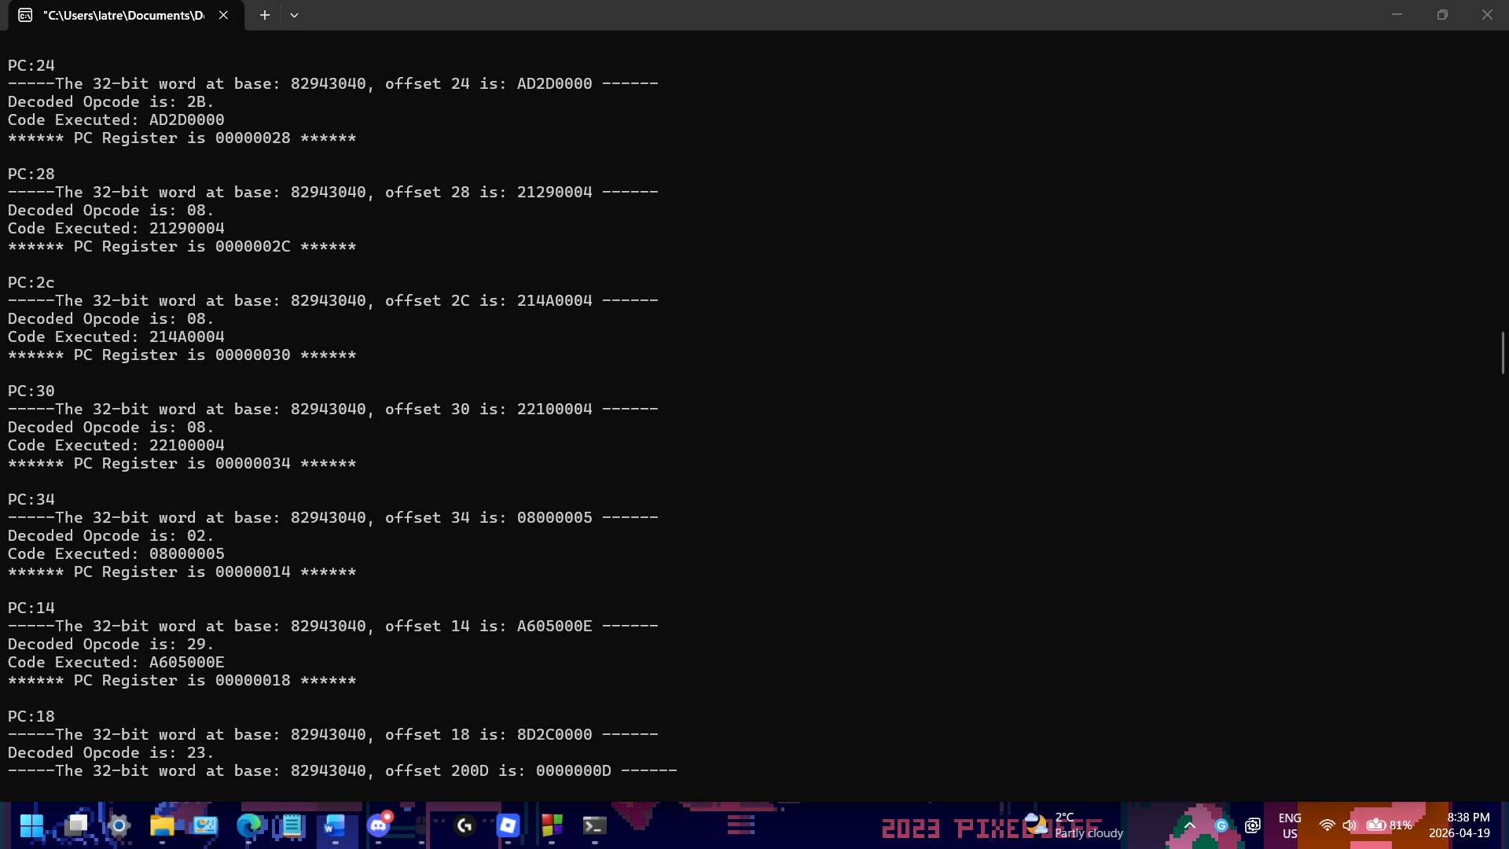
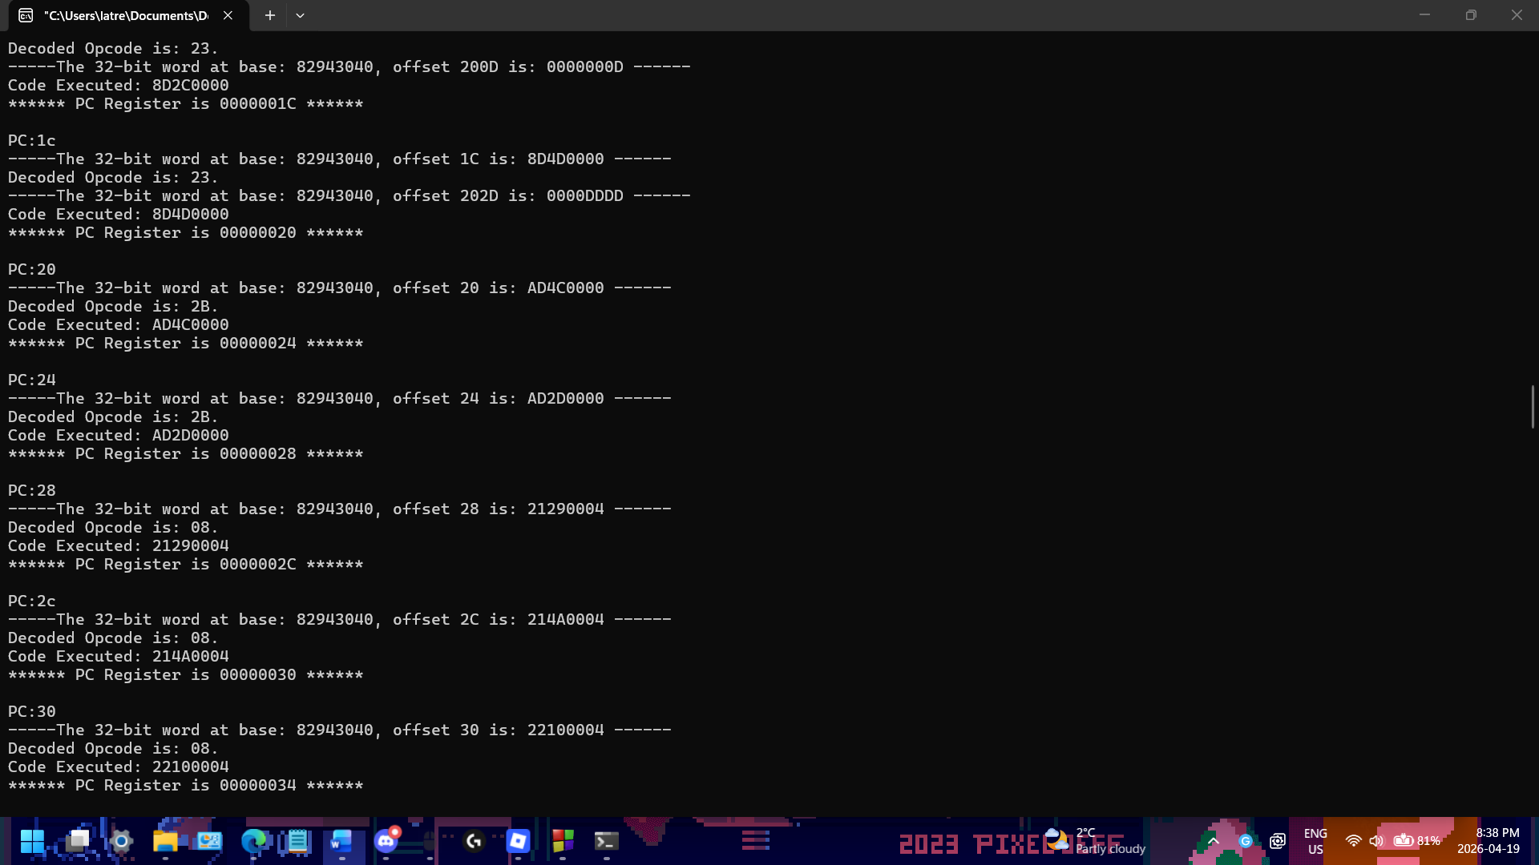
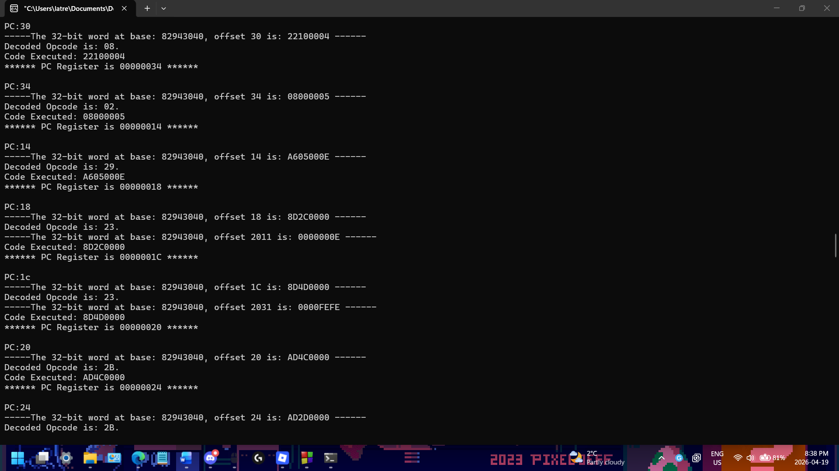
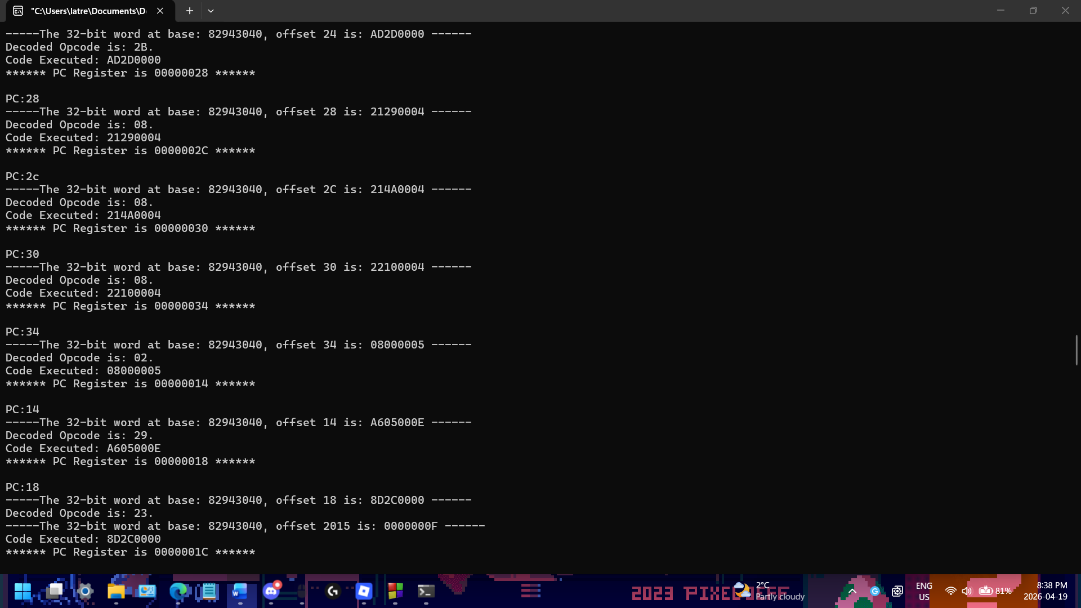
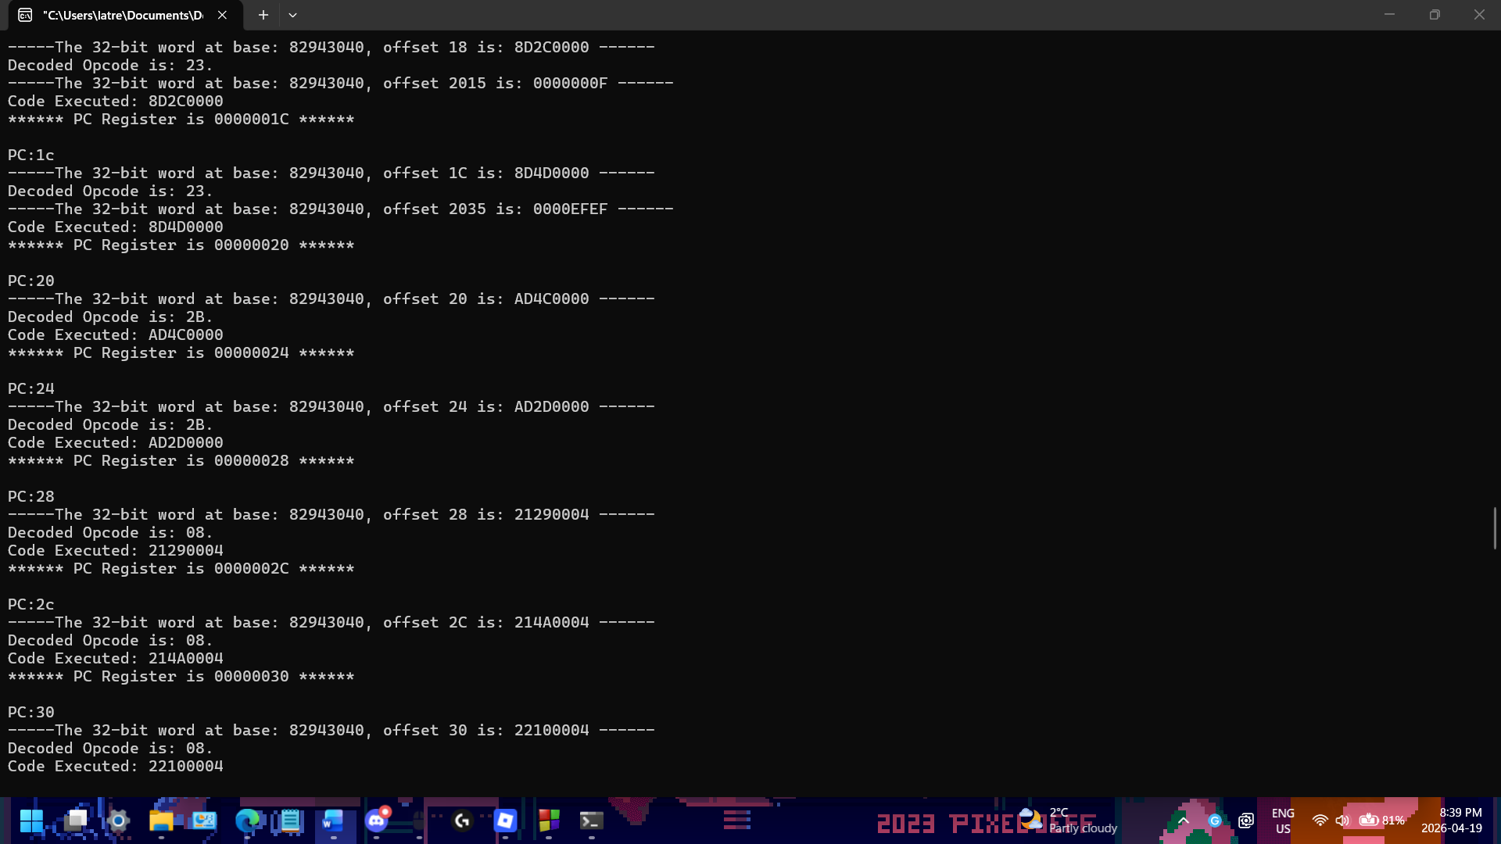
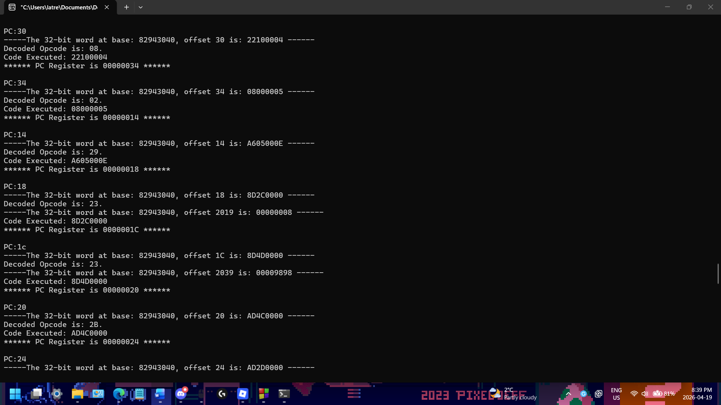
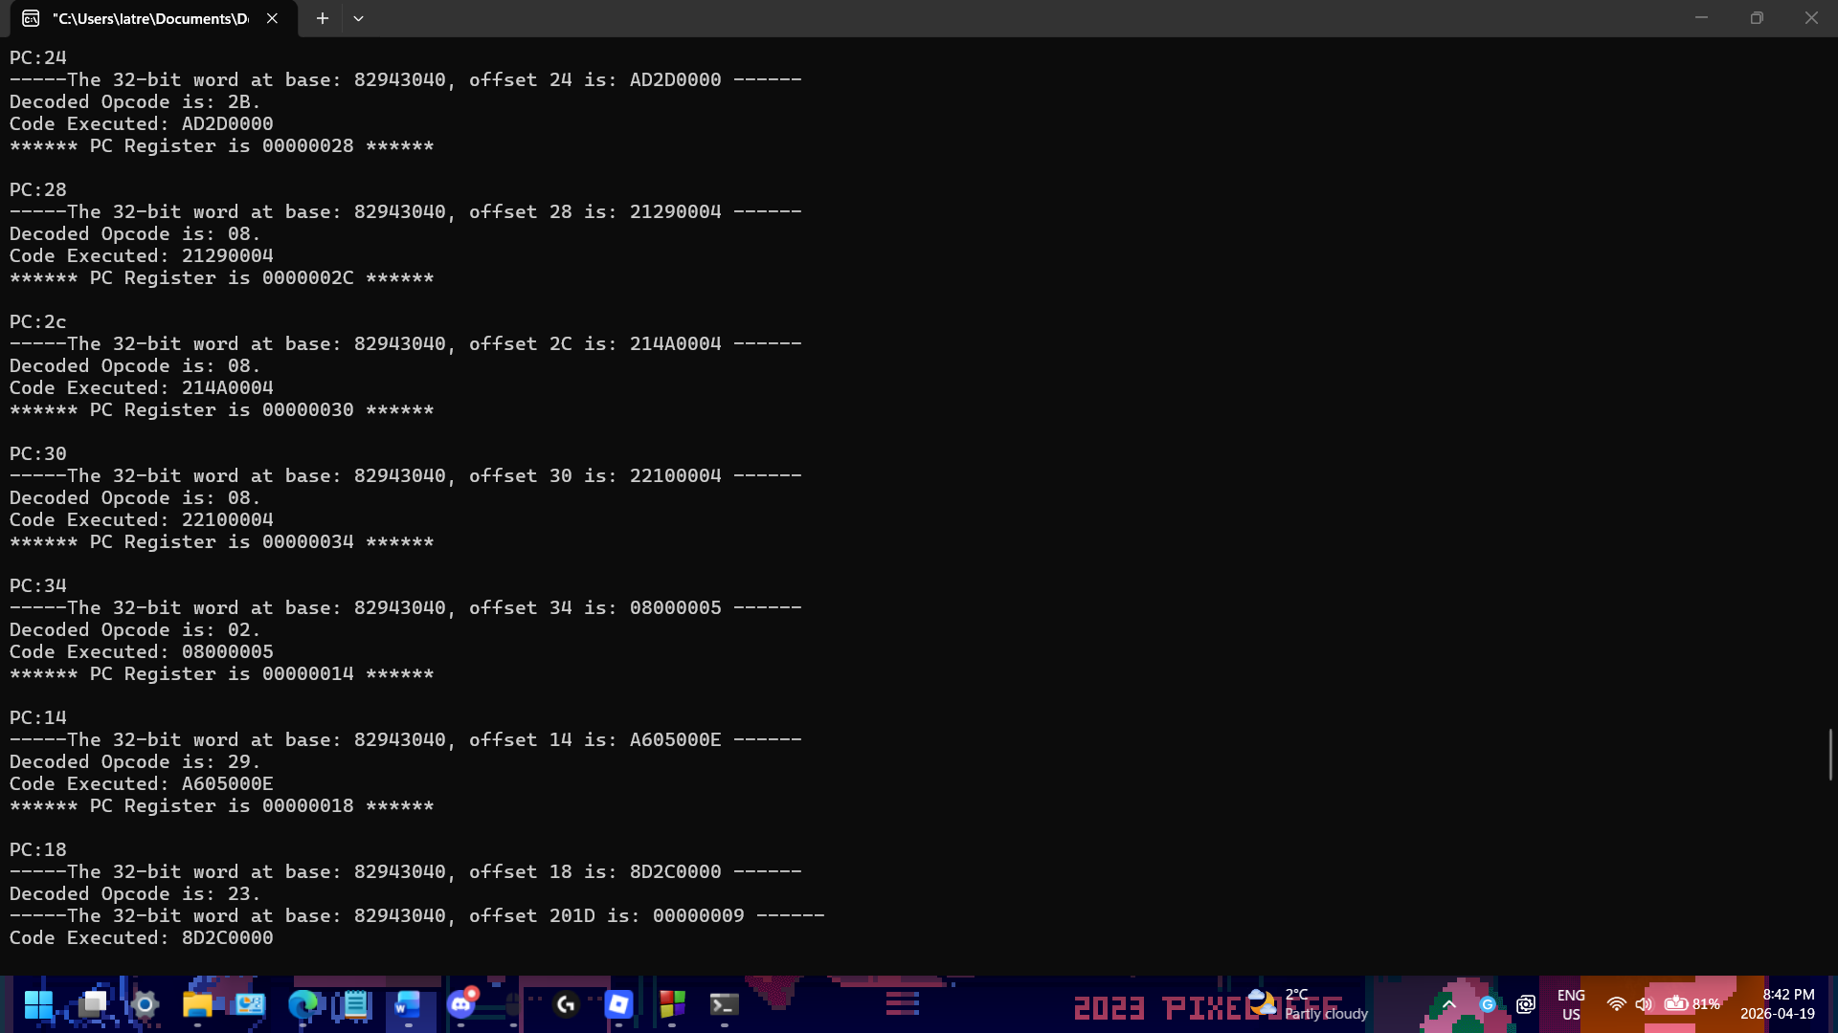
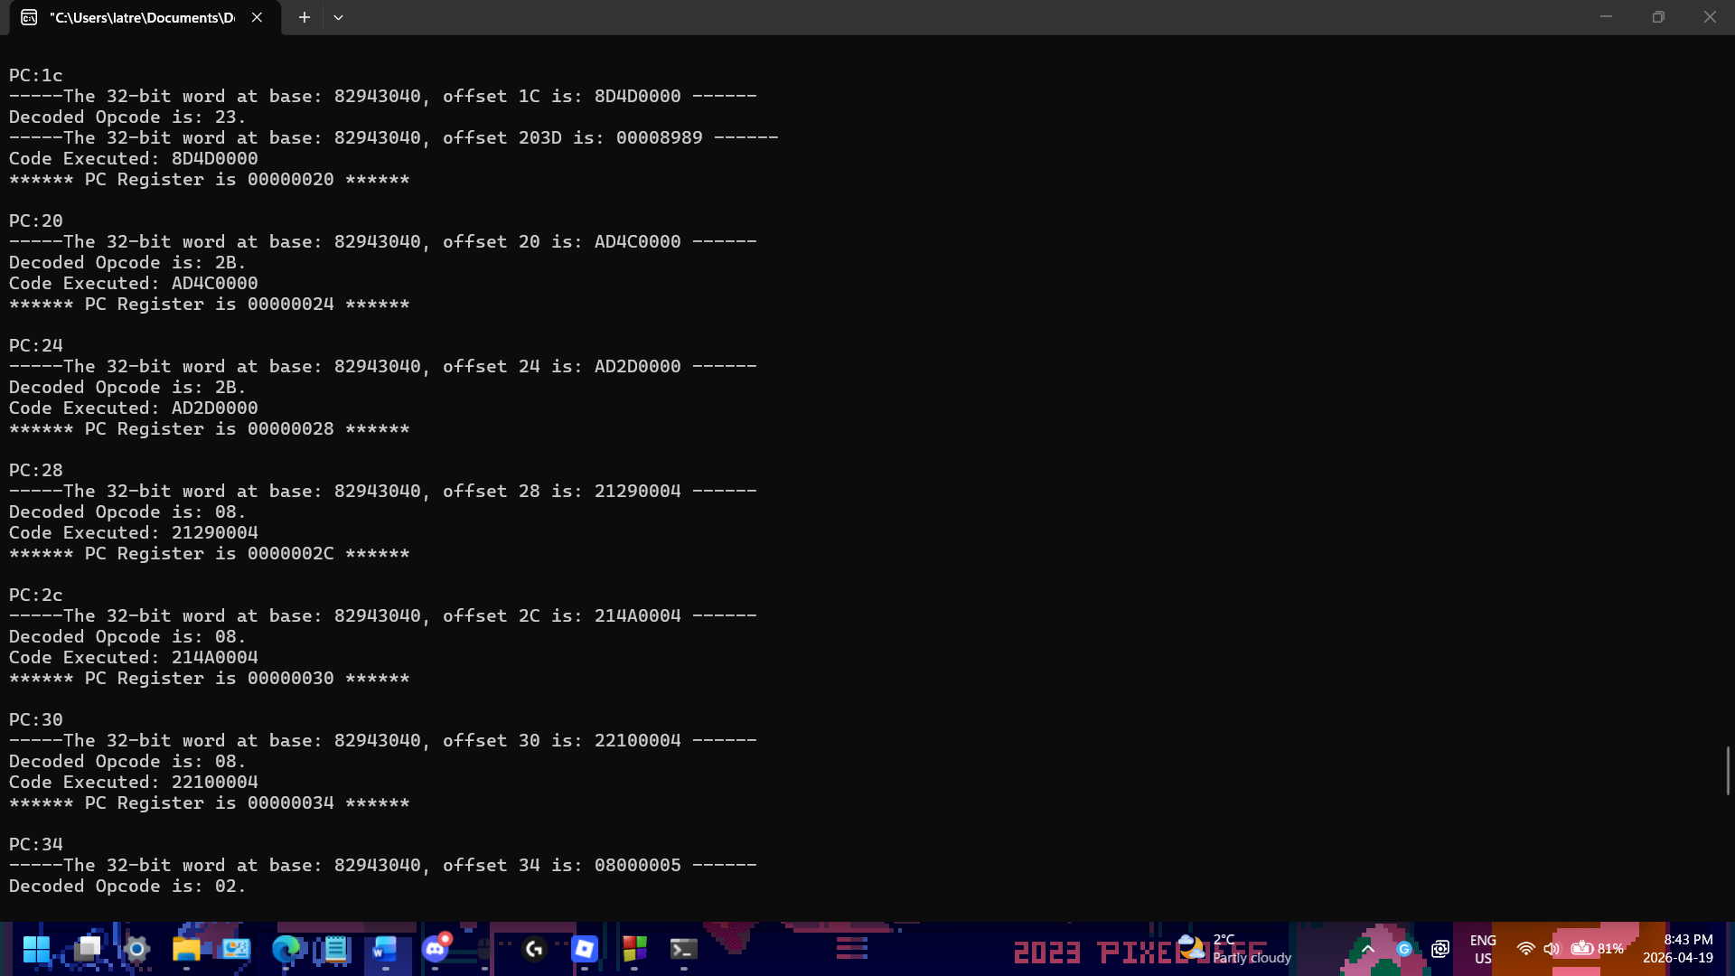
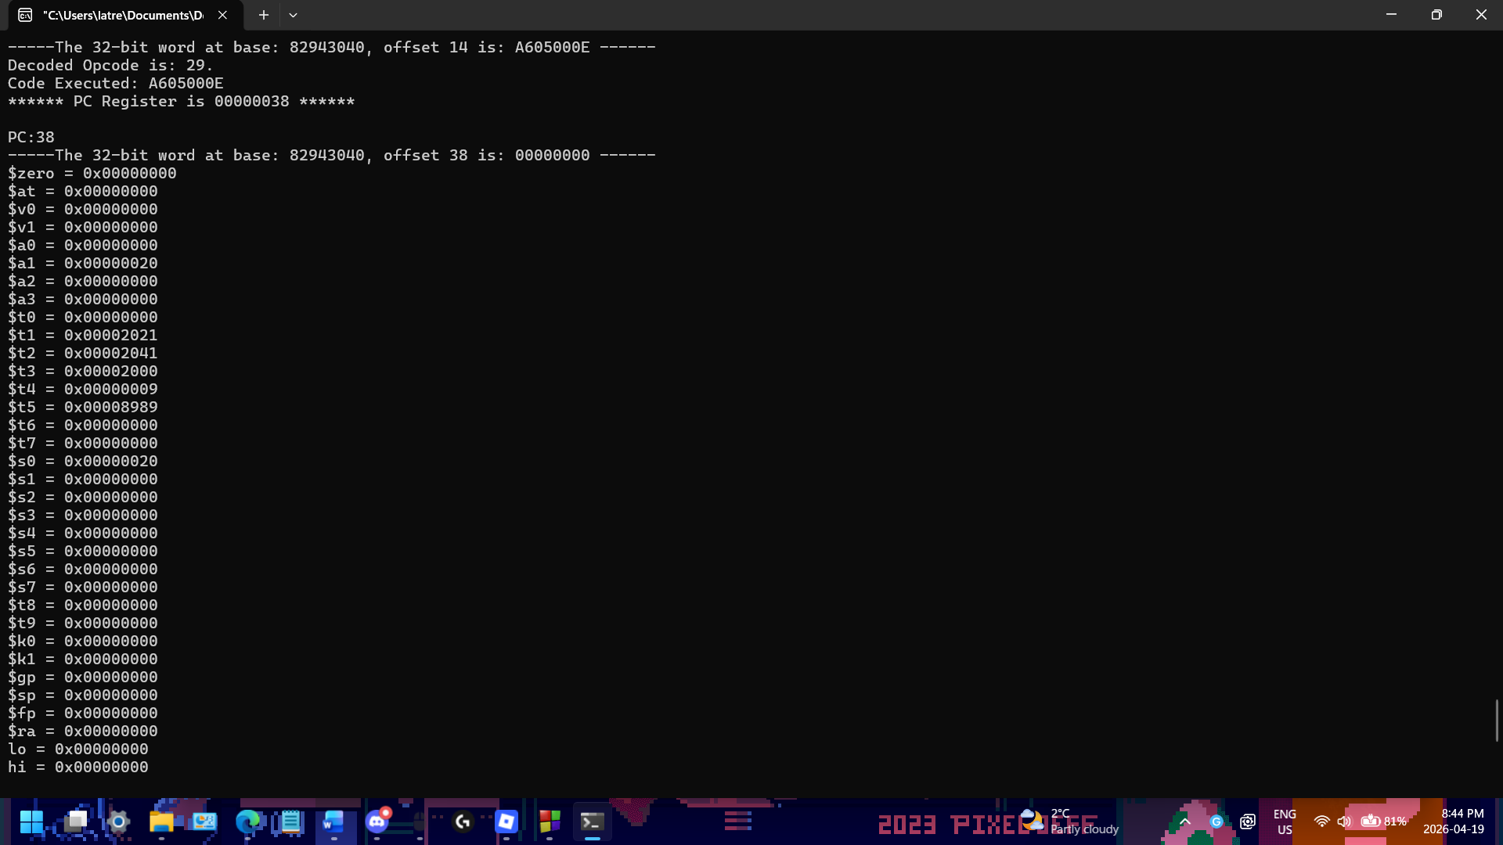
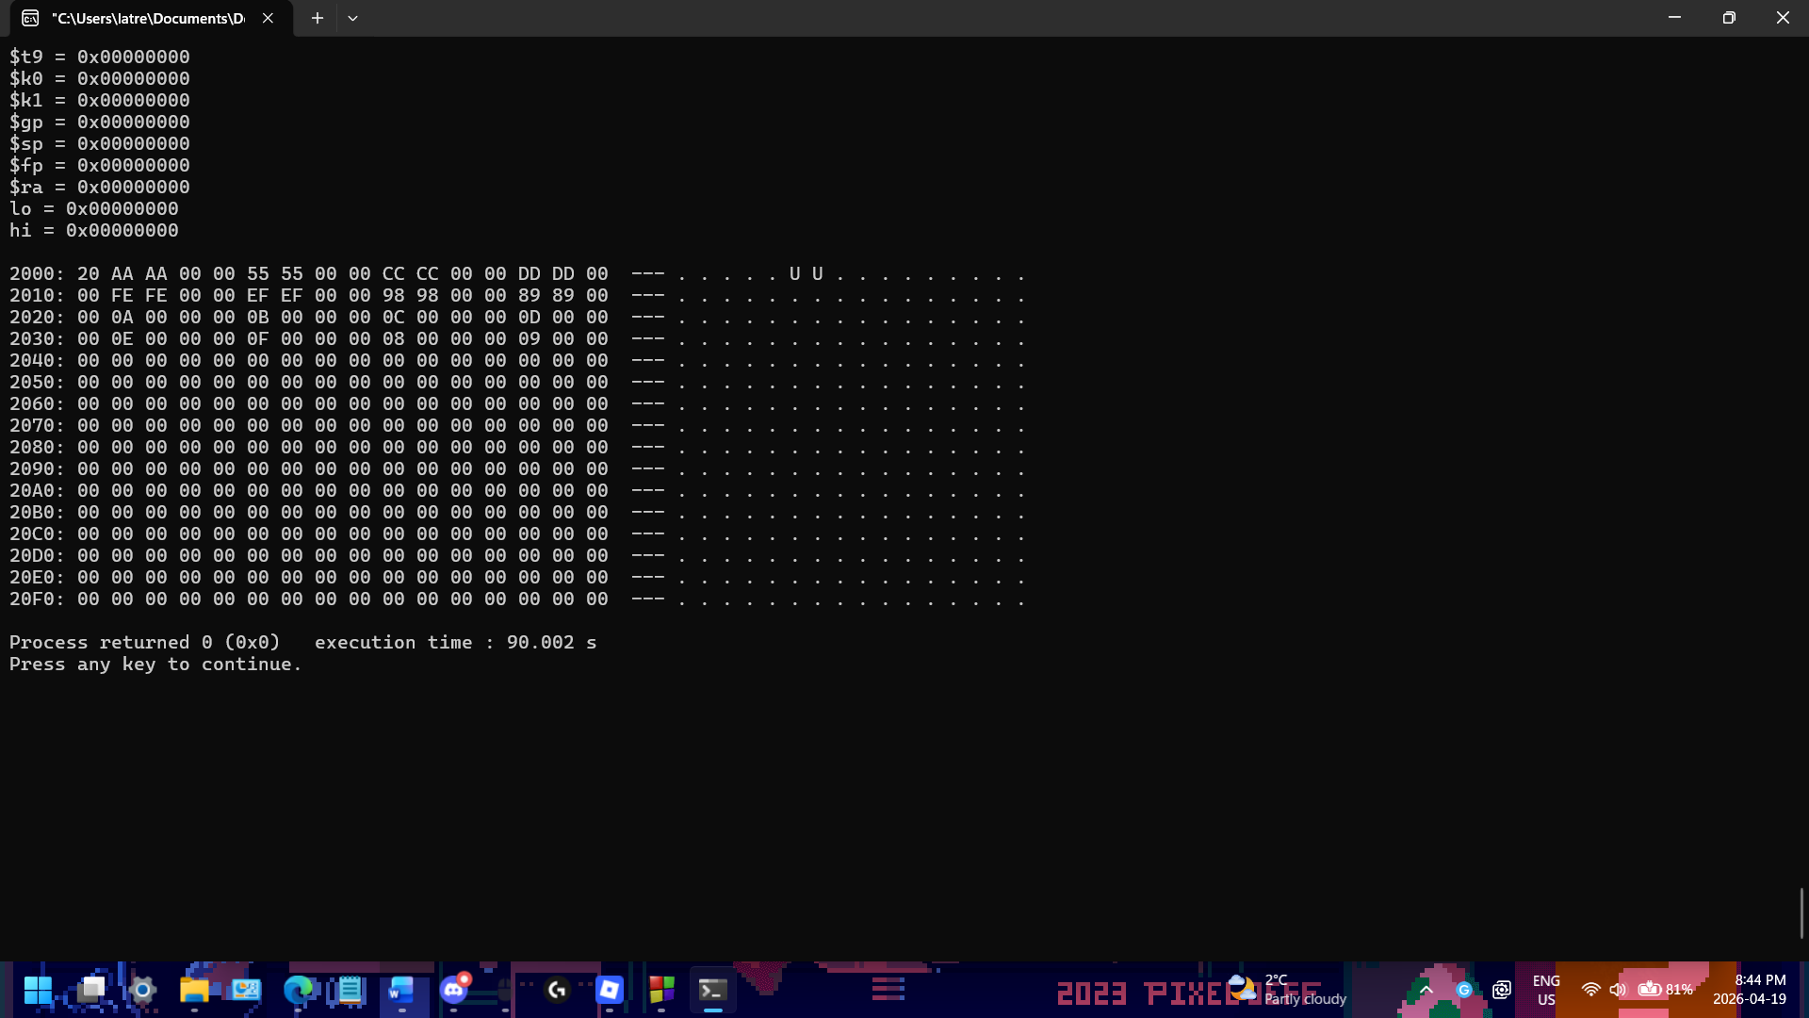

- The lab report is due on the blackboard.
- Answer this question in the text with your submission: (20%)
  - Please briefly describe the function of the code MIPS.asm.
The mips.asm code swaps the content of 32-byte word arrays, testdata1 and testdata2, which is stored in the data section. It then loads the base addresses of both arrays and counter var in the registers, then starts a loop counter, and iterates 8 times, each time reading a word from each array and writing it back to the opposite array. Then once all the 32 bytes have been swapped the bge instruction checks that the loop is finished and ends.

